|  |  |  |  |  |  |  |  |  |  |  |  |
| --- | --- | --- | --- | --- | --- | --- | --- | --- | --- | --- | --- |
|  | | **Hope Foundation’s,**  **Finolex Academy of Management and Technology, Ratnagiri** | | | | | | | | | |
| **Department of Information Technology** | | | | | | | | | |
| Subject name: OLAP LAB | | | | | | | | Subject Code: ITL503 | | | |
| Class | | TE IT | | Semester – V (CBCGS) | | | | Academic year: 2018-19 | | | |
| Name of Student | | Kazi Jawwad A Rahim | | | | | **QUIZ Score : 05** | | | | |
| Roll No | | 32 | | | Experiment No. | | | | | 10 | |
| Title**:** Implement dimensions and cubes in an Analysis Services solution. | | | | | | | | | | | |
|  | | | | | | | | | | | |
| 1. **Course objectives applicable:**   **LOB1**- 1. Implement dimensions and cubes in an Analysis Services solution.  **2.** Create and deploy multidimensional data cubes | | | | | | | | | | | |
| 1. **Course outcomes applicable:**   **LO1**- Apply the knowledge and skills of multidimensional analysis to analyze and discover trends in data warehouse. | | | | | | | | | | | |
| 1. **Learning Objectives:**  * To be able to design considerations for implement an ETL solution. * Learn to create On-Line Analytical Processing (OLAP) cubes using Business Intelligence tools and leverage the Analysis Services administrative tools to better manage and maintain your data. | | | | | | | | | | | |
| 1. **Practical applications of the assignment/experiment:**  * Business/ Enterprise application: Sales and reporting, Budgeting | | | | | | | | | | | |
| **5. Prerequisites**: Knowledge of Data warehouse, Basic working knowledge of SQL Server like working with tables, views. | | | | | | | | | | | |
| **6. Hardware Requirements**:   1. PC with 4GB RAM, 500GB HDD,   **7. Software Requirements:**  1. SQL Server 2012 2. SSIS -Sql server Integration services | | | | | | | | | | | |
|  | | | | | | | | | | | |
| **8. Quiz Questions (if any): (Online Exam will be taken separately batch wise, attach the certificate/ Marks obtained)**  https://goo.gl/DbJcxD | | | | | | | | | | | |
|  | | | | | | | | | | | |
| **9. Experiment/Assignment Evaluation:** | | | | | | | | | | | |
| **Sr. No.** | **Parameters** | | | | | | | | **Marks obtained** | | **Out of** |
| **1** | Technical Understanding (Assessment may be done based on Q & A **or** any other relevant method.) Teacher should mention the other method used - | | | | | | | |  | | 6 |
| **2** | Neatness/presentation | | | | | | | |  | | 2 |
| **3** | Punctuality | | | | | | | |  | | 2 |
| **Date of performance (DOP)** | | |  | | | **Total marks obtained** | | |  | | **10** |
| **Date of checking (DOC)** | | |  | | | **Signature of teacher** | | | | | |

**Results :-**

Click **Next**

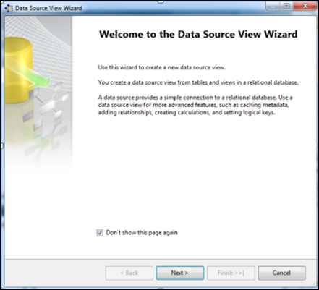

Select**Relational Data Source**we have created previously (Sales_DW)-> Click **Next**

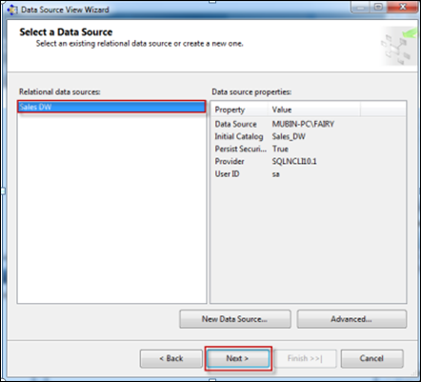

First move your **Fact Table** to the right side to include in object list.

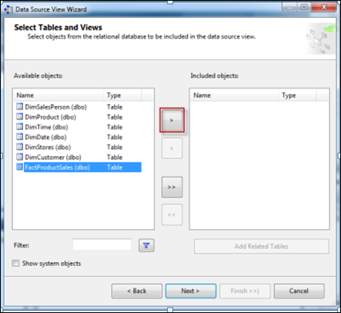

SelectFactProductSales Table -> Click on Arrow Button to move the selected object to Right Pane.

Now to **add dimensions** which are **related** to your **Fact Table**, follow the given steps:

Select **Fact Table** in Right Pane (Fact product Sales) -> Click On**Add Related Tables**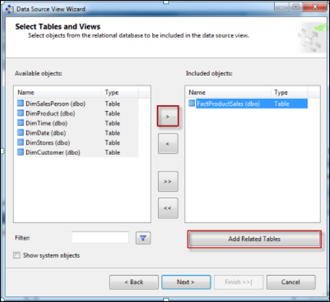

It will add all associated dimensions to your Fact table as per relationship specified in your SQL DW (Sales_DW).

Click **Next**.

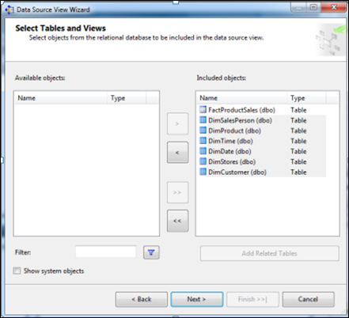

Assign**Name (SalesDW DSV)->**Click**Finish**

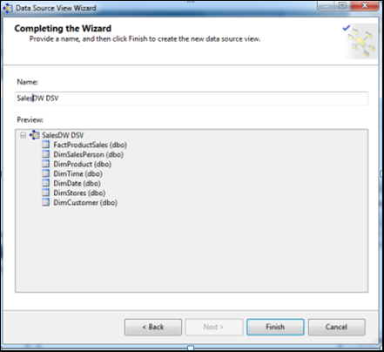

**Now Data Source View is ready to use.**

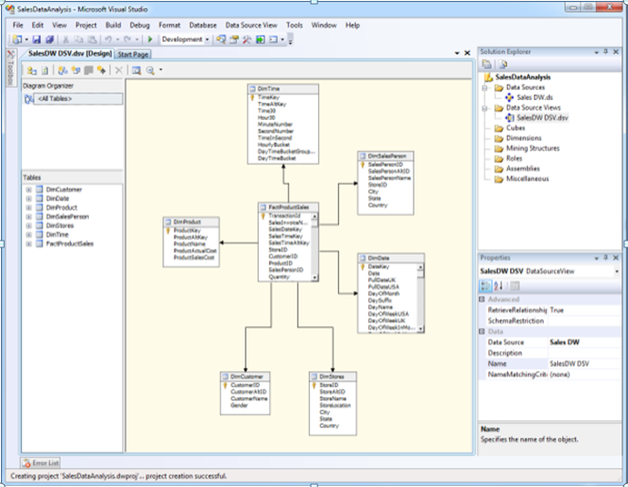

**Creating New Cube**

In Solution Explorer -> Right Click on **Cube->**Click**New Cube**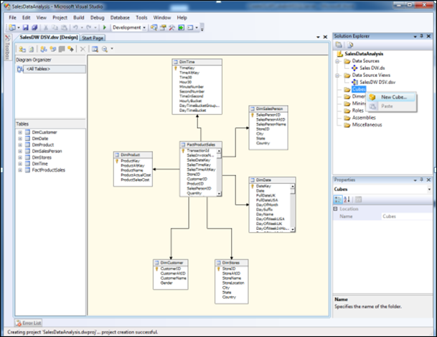

Click**Next**

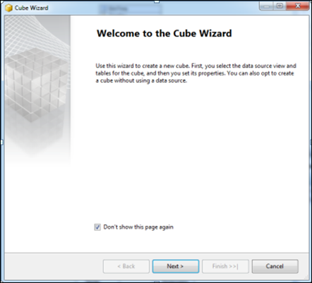

Select Option**Use existing Tables ->**Click**Next**

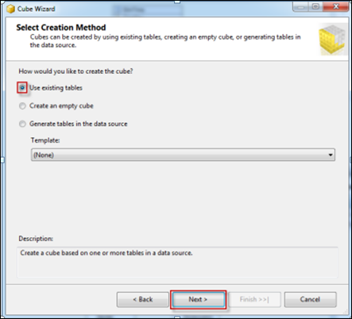

Select Fact Table Name from**Measure Group Tables (FactProductSales) ->**Click**Next**

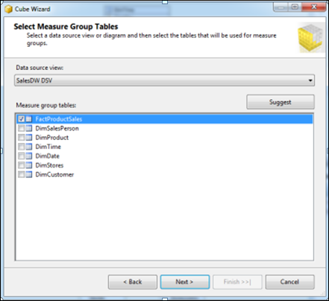

Choose**Measures**from the List which you want to place in your Cube --> Click **Next**

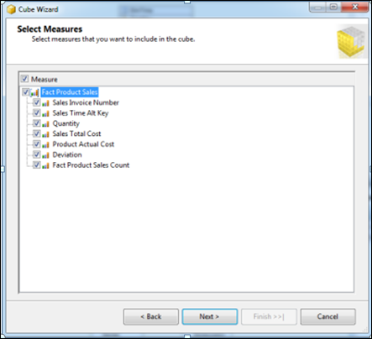

Select All **Dimensions** here which are associated with your Fact Table-> Click **Next**

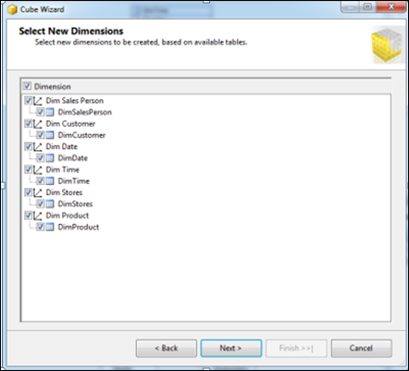

Assign **Cube Name** (SalesAnalyticalCube) -> Click **Finish**

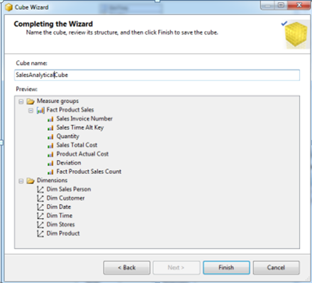

Now your Cube is ready, you can see the newly created cube and dimensions added in your solution explorer.

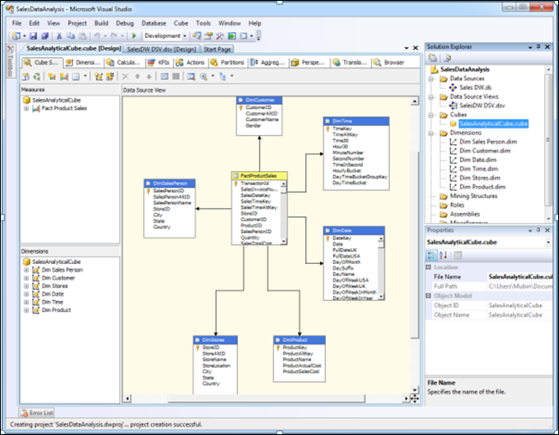

**Dimension Modification**

In Solution Explorer, double click on dimension **Dim Product ->**Drag and Drop Product Name from Table in Data Source View and Add in Attribute Pane at left side.

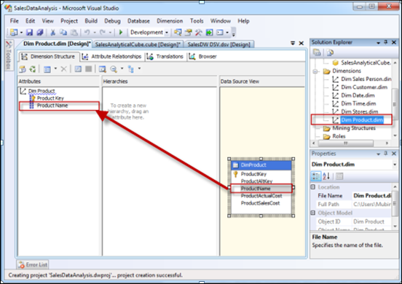

**Creating Attribute Hierarchy In Date Dimension**

Double click On **Dim Date** dimension -> Drag and Drop Fields from Table shown in Data Source View to Attributes-> Drag and Drop attributes from leftmost pane of attributes to middle pane of Hierarchy.

Drag fields in sequence from Attributes to Hierarchy window (Year, Quarter Name, Month Name, Week of the Month, Full Date UK),

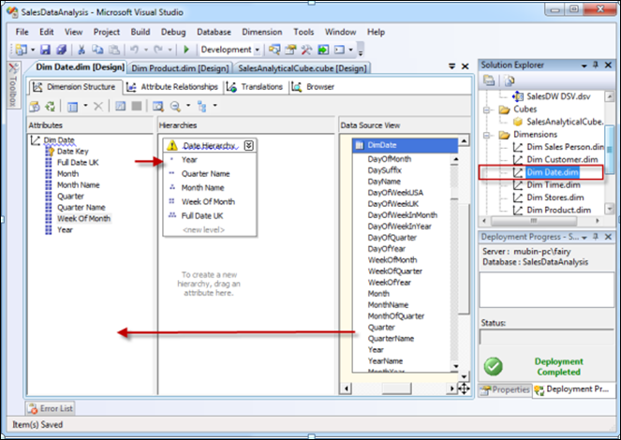

**Deploy the Cube**

In Solution Explorer, right click on Project Name (SalesDataAnalysis) -- > Click **Properties**

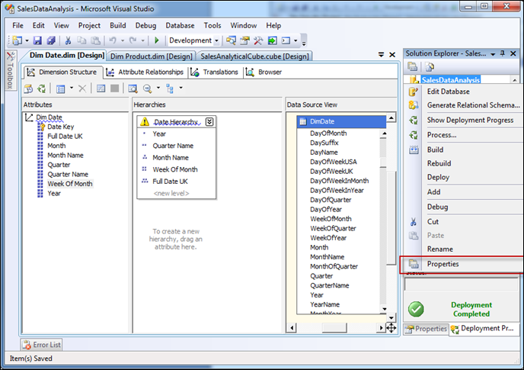

Set **Deployment Properties** First

In Configuration Properties, Select Deployment-> Assign Your SQL Server Instance Name Where Analysis Services Is Installed (*mubin-pc\fairy*) (*Machine Name\Instance Name*) -> Choose Deployment Mode **Deploy All**as of now ->Select Processing Option **Do Not Process**-> Click **OK**

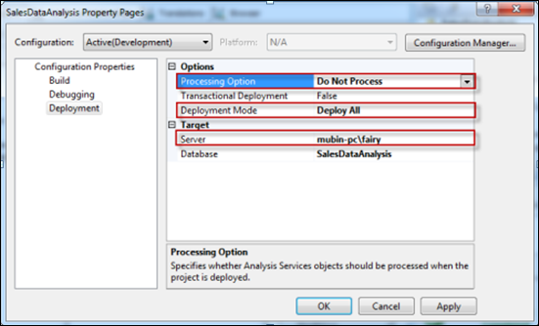

In Solution Explorer, right click on **Project Name** (SalesDataAnalysis) -- > Click **Deploy**

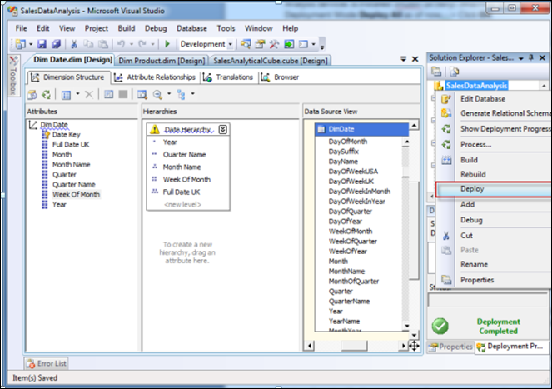

Once Deployment will finish, you can see the message**Deployment Completed**in deployment Properties.

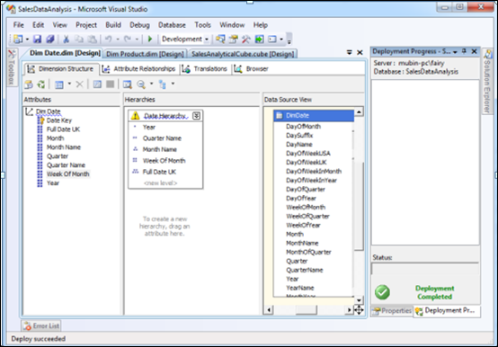

**Process the Cube**

In Solution Explorer, right click on Project Name (SalesDataAnalysis) -- > Click **Process**

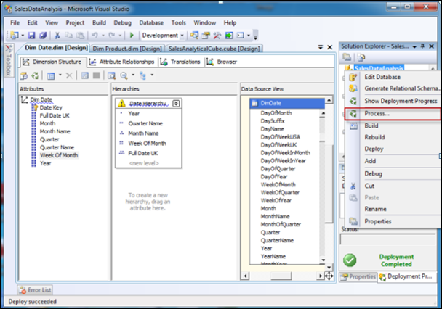

Click on **Run** button to process the Cube

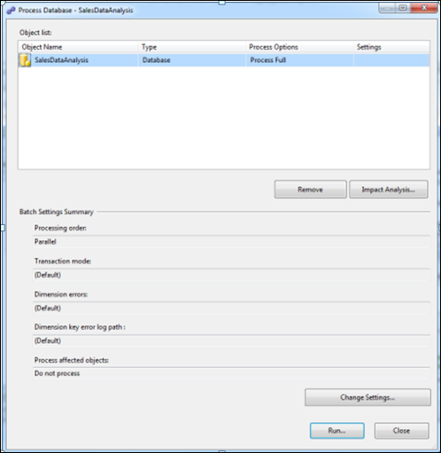

Once processing is complete, you can see **Status** as **Process Succeeded**-->Click **Close**to close both the open windows for processing one after the other.

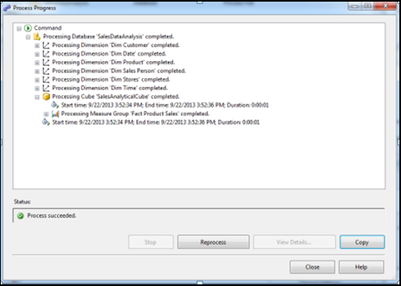

**Browse the Cube for Analysis**

In Solution Explorer, right click on Cube Name (SalesDataAnalysisCube) -- > Click **Browse**

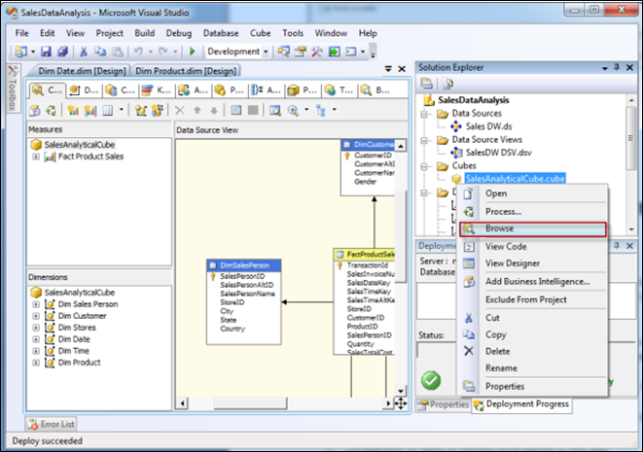

Drag and drop measures in to Detail fields, & Drag and Drop Dimension Attributes in Row Field or Column fields.

Now to **Browse Our Cube**

1. Product Name Drag & Drop into Column
2. Full Date UK Drag & Drop into Row Field
3. FactProductSalesCount Drop this measure in Detail area

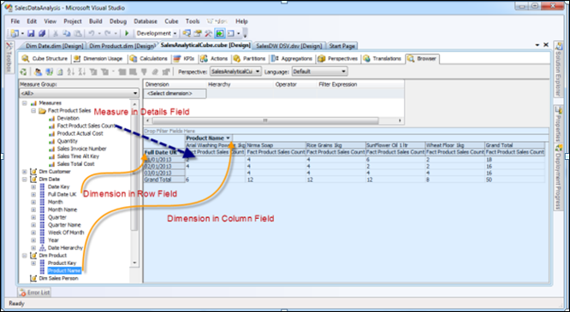

**References**:

1. W. H. Inmon, "Building the Data Warehouse", 3rd edition.

2. https://www.lynda.com/Excel-tutorials/Cubes/172384/186759-4.html

3. https://docs.oracle.com/cd/B10501_01/server.920/a96520/concept.htm

4. http://www2.cs.uregina.ca/~dbd/cs831/notes/dcubes/dcubes.html